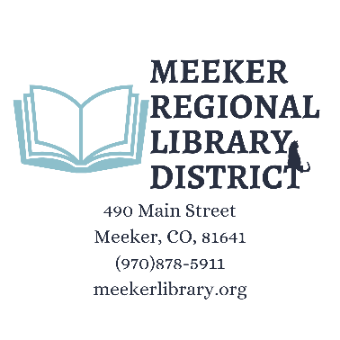
June 9, 2026 Board Workshop
5:30pm-7pm
The Meeker Regional Library District exists solely to enhance the quality of each individual library user by upholding to the Library Bill of Rights, the Freedom to Read, Patron Privacy, Art in the Library and other statements included in this document.
The Library recognizes and appreciates its status as the only free and inclusive cultural and educational institution with the community and endeavor to continually expand the opportunities we make available to our patrons. We will strive to mitigate, if not overcome, the limitations our community's geographic situation places on our informational, educational and recreational choices by exploring advances in telecommunication technology as well as by more traditional means of library service.
The Workshop is open to the public. No action will be taken.
1. Call meeting to order
2. Pledge of Allegiance
3. Discussion Items
- Discuss Proposed First Amendment to Library Board Bylaws
- Discuss Benefits Policy
- Discuss April 29, 2026 and May 27, 2026 Board Meeting Minutes
4. Board Member Comments

