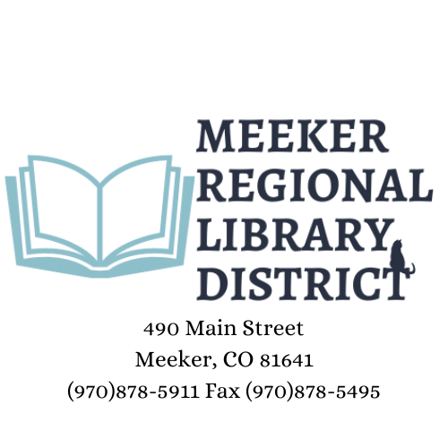

April 2, 2024 Special Board Meeting 5pm

I Call meeting to order

II Read and approve minutes of previous meeting

III Three-minute community member comments

IV New Business

A Board Training with the Colorado State Library